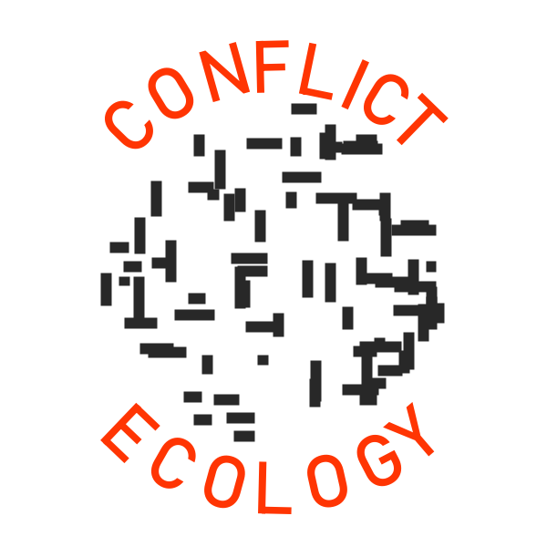Student Research Assistant — Satellite Imagery Interpretation
Conflict Ecology in CEOAS @ Oregon State University
Undergraduate · Student hourly · Part-time / Flexible hours · Remote sensing & GIS

Position overview
We're looking for a motivated OSU undergraduate student to join Conflict Ecology (www.conflict-ecology.org) as a paid student hourly research assistant. You'll contribute to a variety of projects by visually interpreting satellite imagery in a variety of humanitarian settings around the world. Your work will directly feed datasets used in humanitarian response and recovery as well as academic research. This position begins in Spring 2026 with a potential to continue through Summer and Fall 2026 for exceptional candidates.

What you'll do
- Interpret and annotate pre- and post-event satellite imagery to identify landscape features of interest
- Follow protocols for labeling and quality-checking imagery using open-source tools including QGIS and Google Earth Engine as well as custom tools for image interpretation and labeling
- Participate in regular check-ins and help document methods and workflows

What we're looking for (required)
- Current OSU undergraduate student in Geography, Environmental Sciences, or a related field
- Interest in satellite imagery, spatial analysis, and/or environmental changes
- Attention to detail in documenting work progress
- Interest in learning new software tools
- Ability to commit to ~5 hours per week, meet weekly deadlines, and commit to regular communications

Preferred (not required)
- Interest in human rights, peace and conflict studies, and/or humanitarian research
- Basic familiarity with GIS software and satellite imagery; coursework would be sufficient
- Familiarity with open-source mapping tools such as QGIS, Google Earth, and/or Collect Earth Online
- Basic familiarity with cloud (Google Drive, Box) and Windows or Mac computer file systems

Compensation & details
- Student hourly position, paid at $15/hour
- Flexible scheduling; work is primarily remote with weekly in-person meetings
- Pending available funding, research assistants may be invited to continue into Summer and Fall 2026

How to apply
Send an email to Prof. Jamon Van Den Hoek (vandenhj@oregonstate.edu) with the subject line "satellite image analyst application." Please include:
- A current CV
- A list of relevant courses with grades – no need for a full/official
- A brief statement of interest describing why this work appeals to you
- Your general availability by day of week for the Spring 2026 term
Please submit your application by May 8th 2026. Applications will be reviewed on a rolling basis.

